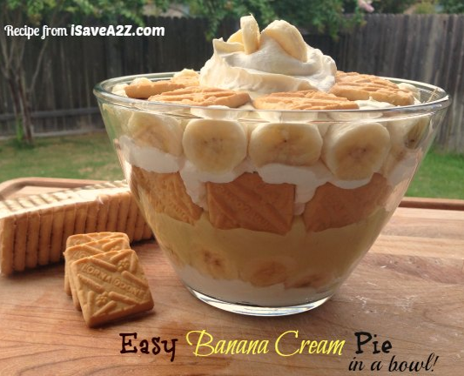

Easy Banana Cream Pie Recipe
By Jennifer Garza, iSaveA2Z.com,
If you are looking for a simple, yet delicious dessert, this Easy Banana Cream Pie Recipe is for you! It contains shortbread cookies that act as the crust of the pie making it a no baking required dessert! I love it and I bet you will too.
Ingredients:
- 1 package or Lorna Doone Shortbread cookies or Pepperidge Farm Chessman Shortbread cookies
- 2 small packets of Jell-O Instant Banana Cream Pudding
- 4 Bananas
- 1 12 oz container of frozen whipped topping (thawed)
- 2 cups cold milk
Prep Time: 10 minutes
Cook time: 0 minutes
Yield: 8 Servings
Instructions for Easy Banana Cream Pie:
Start by making the instant banana cream pudding according to the instructions on the package by mixing 2 cups of cold milk per pudding package. Stir completely and wait for it to set. Once it has set I folded in about 1/2 of the whipped cream to the pudding mixture for a light and fluffy texture.
Next, add the first layer of shortbread cookies at the bottom of your bowl or pan (whichever you prefer). The next layer will be sliced bananas. Add a layer of the Banana Cream pudding mixture you prepared earlier. Now add a layer of whipped cream. Repeat these layers until you run out of room or ingredients. Top with the remaining a dollop of whipped cream and bananas on the top. Voila! That’s it!
Read more: http://www.isavea2z.com/easy-banana-cream-pie-recipe/#ixzz2flpGfIY4
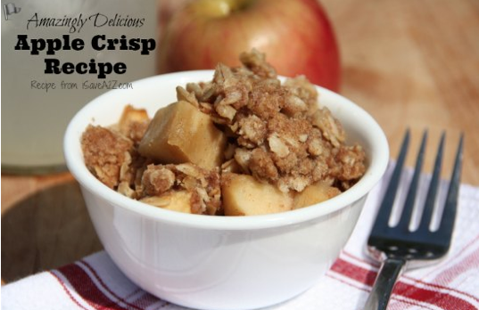

Best Apple Crisp Recipe
By Jennifer Garza, iSaveA2Z.com,
Today I was in a mood to do some baking but it had to be a quick and easy recipe because it’s really hot in Texas in the summer. The thought of turning on the oven is just not good. However, my cravings for something sweet quickly overpowered that thought. I have tons of apples so I decided to make my Best Apple Crisp Recipe!
Ingredients:
- 4 or 5 medium apples of your choice
- 3/4 cup packed light brown sugar
- 1/2 cup all purpose flour
- 3/4 cup old fashioned oats
- 1/3 cup real butter (softened to room temperature)
- 1 teaspoon ground cinnamon
- 1/2 teaspoon nutmeg or pumpkin pie spice
- Optional: Top with Vanilla Ice Cream
Prep Time: 15 minutes
Cook time: 30 minutes
Yield: 8 Servings
Instructions for the Best Apple Crisp ever:
I start off by preheating my oven to 350 degrees. Grease a 8 inch square pan. Cut the apples into small pieces and lay them in the bottom of the pan. In a medium bowl, combine all the ingredients and mix it well. Sprinkle it over the apples. Bake it for about 30 minutes. Serve it warm with the optional Ice cream over the top of it. Voila! That’s it!
Read more: http://www.isavea2z.com/the-best-apple-crisp-recipe/#ixzz2flpaOVCk
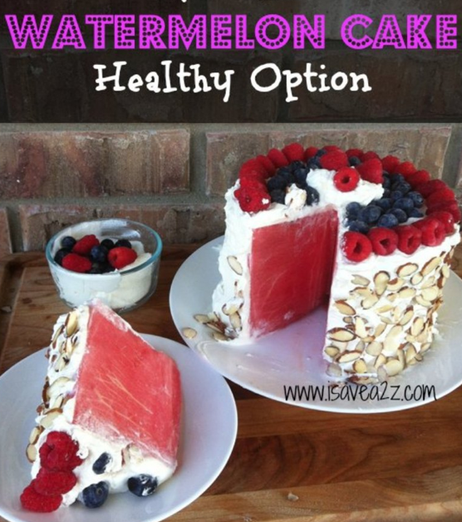

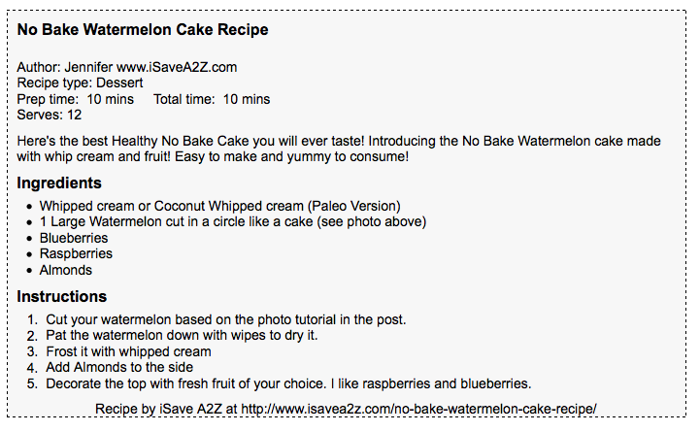

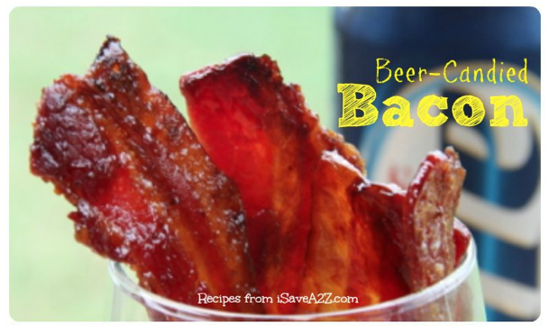

Beer Candied Bacon Strips
By Jennifer Garza, iSaveA2Z.com,
Beer candied bacon strips! Have you tried them? Have you even heard of them before? If you are looking for a sweet, salty, crunchy, gooey and irresistible snack, then you have just found your match! This recipe is a favorite around football season. All the guys love this one!
Ingredients:
- 10 strips of Thick cut bacon
- 1/4 cup of your favorite beer
- 1/2 cup brown sugar
Prep Time: 5 minutes
Cook time: 30 minutes
Yield: 10 Servings
Instructions for Beer Candied Bacon Strips:
I started off by baking the thick, high quality strips of bacon on 350 degrees for about 20 minutes on a shallow baking sheet. Until they were crispy. I immediately transferred them to a cooling rack. Once they completely dripped free of the oil and cooled I transferred them to a different deep baking dish. I added a 1/2 cup of brown sugar sprinkled over the cooked bacon then I added 1/4 cup of Miller Lite beer. If you are baking more than 10 strips you can double this recipe. I would always add more brown sugar than beer though. Then I heat bacon again on 400 degrees for about 10 minutes. Just enough time for the brown sugar to start bubbling as seen in the collage photo above. Remove it from the oven and immediately transfer it back to the wire rack to cool. Careful it’s extremely hot! One it’s cooled enjoy it!
Read more: http://www.isavea2z.com/beer-candied-bacon-strips/#ixzz2flqWIOEu

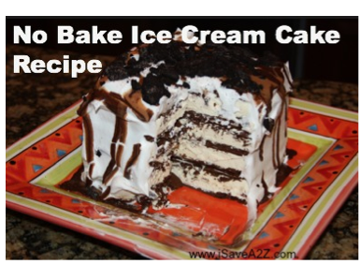

Ice Cream Sandwich Cake Recipe

Ice Cream Sandwich Cake Recipe Ingredients
- 1 box of twelve Ice Cream Sandwiches (or two boxes for a large cake)
- 1 tub of Whipping Cream
- Magic Shell Caramel
- Magic Shell Chocolate
Optional:
- Oreo Cookies (crumbled into pieces)
- Candy bars (diced into pieces) Snickers, Hersheys, Twix, Reeses, M&M’s, Nestle Crunch, etc… (My favorite is the Skor chocolate candy bar because the inside hardened caramel center gives a nice crunch)
- Nuts
- Prep Time: 10 minutes
- Cook time: 0 minutes
- Yield: 12 Servings
Directions:
I start off by unwrapping all the ice cream sandwiches and stacking them layer by layer but each layer if faced an opposite direction as the one before. Drizzle Magic Shell between each layer. This provides a glue to hold the layers together. (Tip: I find the higher I make this, the more elegant it looks)
After I’ve completed all of my layers, I spread Whip Cream on the top and sides of the cake. After it is completely covered in Whip Cream, I drizzle Caramel and Chocolate Magic Shell topping over the top of the cake and purposely let it drizzle down the sides of the cake too.
Finally you put all the toppings you desire on the top of the cake! The more you add the richer the cake becomes. You can finish the cake at this stage too. Once finished, place it in the freezer for about 20 minutes to make sure it freezes again before you cut into it.
It has an elegant look to in when you cut into it and it tastes absolutely scrumptious!!! The below photo has Oreo Cookies strangled over the top! KIDS LOVE IT!!!
See all the photos here: http://www.isavea2z.com/icecreamsandwichcakerecipe/#ixzz2flr5lxaK

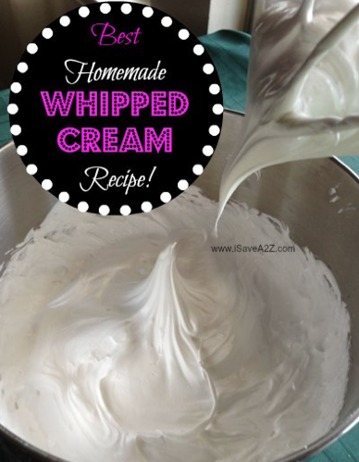

BEST Homemade Whipped Cream
Ingredients:
- 1 cup Heavy Cream (cold)
- 2 tablespoons of Sugar (or Powdered Sugar)
- Optional: 1/2 teaspoon of Pure Vanilla (clear for pure white color)
Double the recipe for big batches
2 cups Heavy Cream (cold)
4 tablespoons of Sugar (or Powdered Sugar)
Prep Time: 5 minutes
Cook time: 0 minutes
Yield: 8 Servings
Instructions for the Best Homemade Whipped Cream:
I usually put my mixer bowl and whisk attachment in the refrigerator to get it cold before I start but this is not necessary.
Add all the ingredients in a mixer.
Start on a low speed to incorporate all the ingredients together then whip on high until you have peaks.
Keep checking the stiffness of your whipped cream because you can get it to different levels. Voila! That’s it!
Read more: http://www.isavea2z.com/best-homemade-whipped-cream-recipe/#ixzz2flrTGC7C

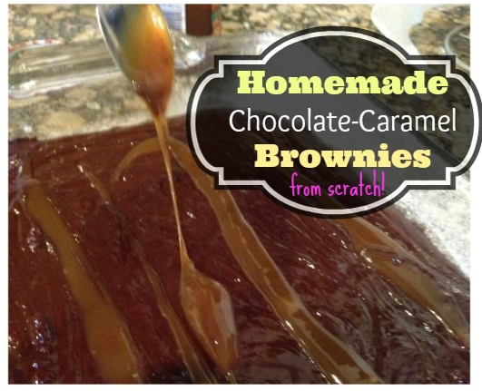

Homemade Chocolate Caramel Brownies Recipe made from Scratch

Ingredients:
- 2 sticks unsalted butter
- 8 ounces plus 6 ounces semisweet chocolate chips
- 3 ounces unsweetened chocolate
- 3 extra-large eggs
- 1 1/2 tablespoons instant coffee granules
- 1 tablespoon pure vanilla extract
- 1 cup plus 2 tablespoons sugar
- 1/2 cup plus 2 tablespoons all-purpose flour, divided
- 1 1/2 teaspoons baking powder
- 1/2 teaspoon kosher salt
- 5 to 6 ounces caramel sauce (here’s what I used in my recipe)
- 2 to 3 teaspoons flaked sea salt (this kind works best)
- Prep Time: 25 minutes
- Cook time: 35 minutes
- Yield: 12 large brownies
Instructions for the Best Homemade Chocolate Caramel Brownies Recipe made from scratch:
Preheat the oven to 350 degrees. Grease and flour a 9×12 baking pan. First combine the butter, 8 ounces of chocolate chips and unsweetened chocolate together and melt it. Allow it to cool to room temperature. In a separate bowl combine the eggs, coffee, vanilla and sugar. Mix it but don’t beat it. Stir the chocolate mixture into the egg mixture. Add a 1/2 cup sifted flour, baking powder and salt to the chocolate mixture. Finally, right before you bake it add the remaining 6 ounces of chocolate chips to the mixture. It was important for you to cool the mixture because if you don’t these chocolate chips will melt. Drizzle the top with caramel. You can add your caramel topping before you bake it for an extra bit of chewy goodness and you can also add some after it’s been baked too. Spread it evening in the greased and floured pan. Bake it for about 35 minutes or until it comes out clean with a knife or toothpick. Be very careful not to over bake it.
Read more: http://www.isavea2z.com/homemade-chocolate-caramel-brownies-recipe-made-from-scratch/#ixzz2flrktUWx

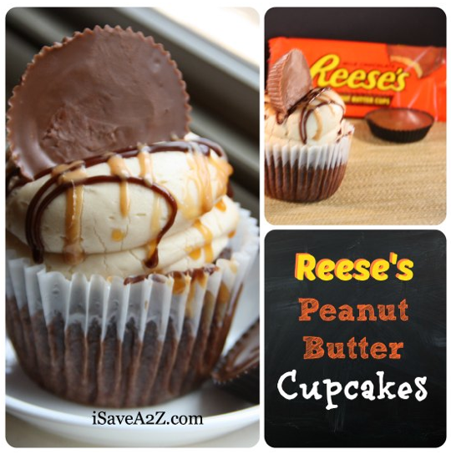

Easy Reese’s Peanut Butter Cupcakes Recipe

Ingredients:
- 1 box Devil’s Food cake mix
- 1 package of mini Reese’s Cups
- 1/2 cup butter
- 1 cup creamy peanut butter
- 3 tablespoons of milk
- 2 cups confectioners’ sugar
- Prep Time: 20 minutes
- Cook time: 25 minutes
- Yield: 18 Servings (depending on size)
Instructions for the Easy Reese’s Peanut Butter Cupcakes Recipe with Fluffy Peanut Butter Buttercream Frosting:
Prepare the Devil’s Food Cake Mix according to the instructions and ingredients on the box. After you add the cake mix to the cupcake paper cups drop a mini Reese’s cup in the middle of the unbaked cupcake. (Tip: I use a medium sized ice cream scooper so all my cupcakes will be the same size) Bake as directed. This will give you a creamy center that taste out of this world delicious! Now it’s time to prepare the Peanut Butter Buttercream frosting. I don’t like a real heavy frosting. I prefer a light and fluffy version I have. Start by mixing the butter and peanut butter in a medium box. Slowly add the confectioners’ sugar. When you feel it start to get thick then add a tablespoon full of milk on scoop at a time until you get the light and fluffy consistency that you like. Don’t add too much milk or else it will be too watery and not spreadable. (Note: to create the icing look on my cupcake I used the Wilton extra large round tip. I started off pressing the frosting down right in the center of the cupcake making one big dollop and then lifting it a bit to create another dollop until I got the height I wanted.) I finished it by topping it with a large Reese’s Peanut Butter Cup and drizzling it with chocolate and caramel. Optional of course. Voila! That’s it! You just made an amazing cupcake the easy way!
Read more: http://www.isavea2z.com/easy-reeses-peanut-butter-cupcakes-recipe/#ixzz2flsmFBMg

Rice Crispy Treat Recipes
Ingredients:
- 6 cups of Rice Crispy Cereal
- 1/4 cup butter
- 1 bag (10.5 oz) miniature marshmallows
Instructions:

Spray a non stick cooking spray on a rectangle baking pan and set aside. Measure out your rice crispy cereal and set aside. I prefer to melt the marshmallows using the stove top method over medium heat. I’ve seen many photo fails with the microwave method. Start by melting the butter. Once the butter is melted, add the marshmallows. Stir repeatedly so you don’t burn them. Once completely melted, I immediately add the Rice Crispy cereal and stir. After the melted marshmallow is completely mixed in I dump the hot ingredients into the baking pan. I grab a little bit of butter and rub it on my clean hands. By doing this I never worry about the treats sticking to my fingers. I then start shaping the rice crispy treats in the pan by spreading it out and pressing down. I add more butter to my hands if needed.
Prep Time: 5 minutes
Cook time: 5 minutes
Yield: 12 large Servings
See all the Rice Crispy Treat Recipes here: (includes Nutella, peanut butter, Chocolate, Cake Batter and more: http://www.isavea2z.com/rice-crispy-treat-recipes/#ixzz2fltBco7N

